Japanese flag biscuits

Ingredients

- Arnotts Malt’O Milk biscuits (or other rectangular sweet biscuits)
- Icing mixture
- Raspberry lollies (or red food colouring for red icing)
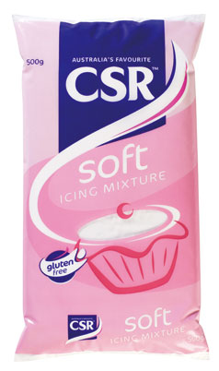

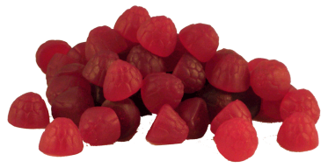
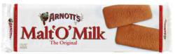

Method

- Make up the icing.
- Spread the white icing on one side of an Arnotts Malt’O Milk biscuit.
- Place the raspberry lolly (or red icing in a dot shape) on top of the icing in the centre.
