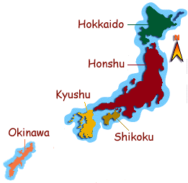
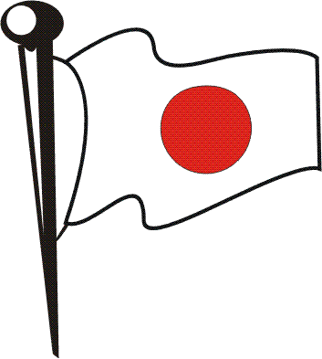
Japan Fast Facts:
Capital: Tokyo
Language: Japanese
Currency: Yen ¥
Population: 128,000,000
Religions: Shinto, Buddhist
Land: Very volcanic, 4 main Islands: Honshu, Hokkaido, Kyushu, Shikoku
Biggest Industry: Motor Vehicles
Colour Japan’s Flag!

Please answer the following questions:

What is the capital city of Japan? _____________________________________
What currency (money) do they use in Japan? ____________________________
How many people are there in Japan? ___________________________________
Name 2 other cities in Japan: __________________________________________
What is the name of Japan’s famous volcano? _____________________________
What are traditional Japanese dresses called? _____________________________
What are 2 popular Japanese sports? ____________________________________
What are 2 popular Japanese foods? ____________________________________
What are 2 popular Japanese arts? _____________________________________
Name a famous Japanese cartoon character: _______________________________
Is there anything else you know about Japan? ______________________________



