[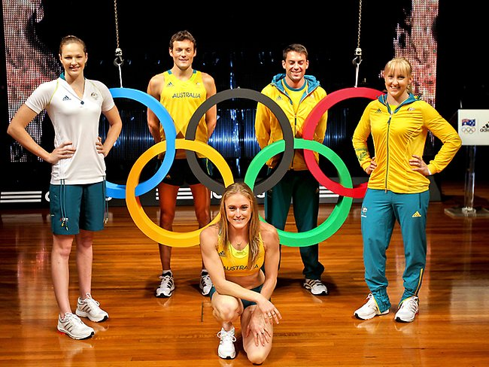](http://www.google.com.au/url?sa=i&rct=j&q=japanese%20olympic%20uniforms&source=images&cd=&cad=rja&uact=8&docid=X6iW9dRF4I78lM&tbnid=L4LPQQpVleV-cM:&ved=0CAUQjRw&url=http://iessanpabloenglish.wordpress.com/&ei=MKXQU5CzDZe78gWAj4DIAg&bvm=bv.71667212,d.dGc&psig=AFQjCNEpmRBCSqv-Do1qbOwgPexSJd1DgA&ust=1406268961207555)

Japan and the Olympics

complete parts a, b, and c in your portfolio

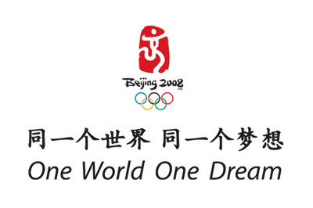[](http://www.powder.com/stories/sochi-olympic-slogan/)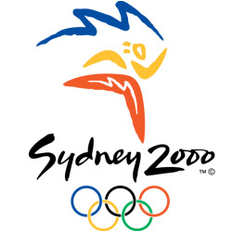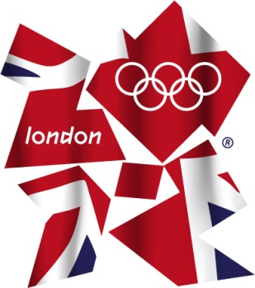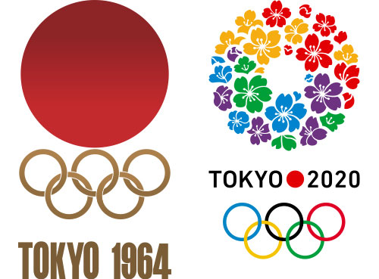

**PART C- Tokyo 2020 Motto**

1. Come up with a motto to accompany your Tokyo 2020 Olympic Team Uniform/Logo.
2. Your motto should be inspiring and motivating!
3. Write 100 words that explain the meaning behind and choice of your motto.

**PART B- Tokyo 2020 Logo**

1. Create an alternate design for the Tokyo 2020 Olympics.
2. Include a 200-500 word annotation that explains your design and why it would be suitable for use at the Tokyo Olympics.

**PART A- Team Uniform**

1. Choose an Olympic sport to design a team uniform for (soccer, basketball, athletics, gymnastics etc.)
2. The following items of clothing are a minimum requirement for your uniform.

* Shoes
* Shorts/Skirt
* Shirt

*Depending on your chosen sport you may wish to include additional items. This can be discussed with your teacher.

1. Your uniform design must be coloured and labelled using the vocabulary/grammar we have focussed on this term **(Romaji and Hiragana!)**

For example,

The shorts are blue.

hanzubon wa aoi desu.

1. In English, write 200-500 words that explain your colour/design choices and how they are relevant to Japan.