**MY FAMILY MEMBERS**



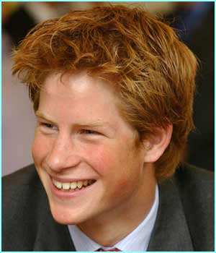

おとうと　 *otouto* (Younger Brother)

‘O’ is the first vowel in BROTHER. It is also the first sound in OTOUTO

はは　 *haha* (Mum)

Hahahaha. Mum is the funny one. She always makes me laugh.



ちち*chichi*(Dad)

あね　 *ane* (Older Sister)

My big sister always wears a necklace

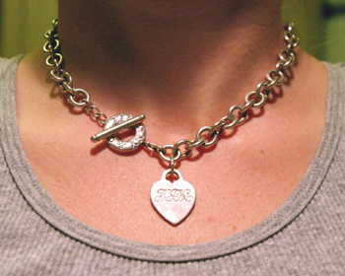

いもうと

*imouto* (Younger Sister)

‘I’ is the first vowel in SISTER. It is also the first sound in IMOUTO

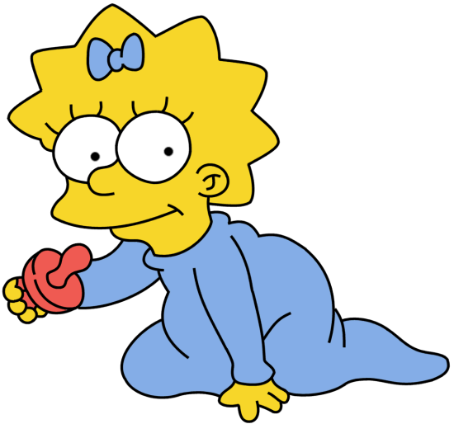



あに　*ani*(Older Brother)

My big brother has a knee injury.