[](http://coloringpagesforkids.info/wp-content/uploads/2008/11/fruit1.gif)[](http://coloringpagesforkids.info/wp-content/uploads/2008/11/fruit5.gif)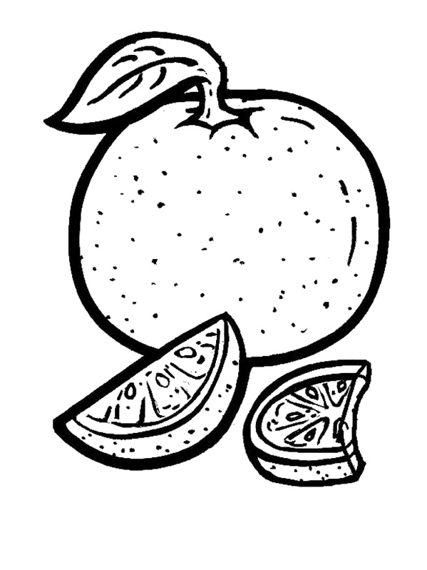[](http://www.supercoloring.com/pages/cucumber-1/)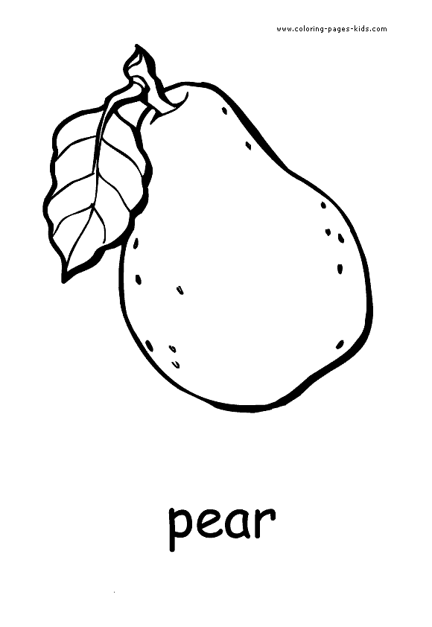[](http://coloringpagesforkids.info/wp-content/uploads/2008/11/fruit2.gif)C:\Documents and Settings\Administrator\Local Settings\Temporary Internet Files\Content.IE5\J7G9539J\MC900384344[1].WMF