**For breakfast 　　あさごはんに**

Look at the pictures below. Write a sentence in Japanese about each meal using the structure below:

**あさごはんにとたまごをたべます。をのみます。**

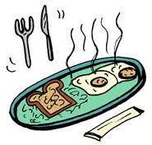E.g.

06:30

________________________________________________________________________________________________________________________________________________________________________

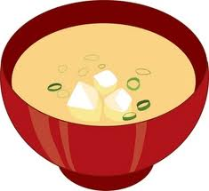　　　1.

07:30



________________________________________________________________________________________________________________________________________________________________________

　　　2. 12:30 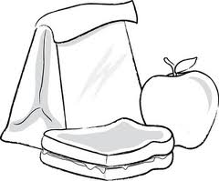

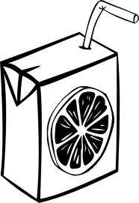



________________________________________________________________________________________________________________________________________________________________________

 3. 14:30

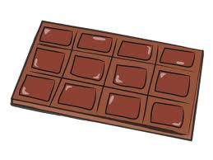

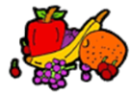 4. 08:30

________________________________________________________________________________________________________________________________________________________________________

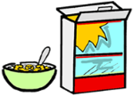

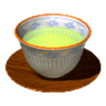

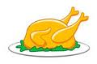 5. 18:30

________________________________________________________________________________________________________________________________________________________________________



