Housing in Japan – Word Search
U B I D E T W A S H I T S U F O
G S T I V U E C N A R T N E R K
N H T N A U S T I H S U K O Y A
I O O I B W T Z H E S L K Y N B
N E K N H A E R C T R O B E M A
I B O G C S R L I R D I H O F T
A O N R D H N H K I I C O C U E
D X O O R R S E A B T R J N P G
O G M O A O T D M I G N U R O F
T N A M O O Y I K N A H I U S M
A L N Y B M L B I G E N K A N I
A N S R P Y E V B U T S U D A N
P G I J U O I B A T H R O O M J
A U O L C L S L I P P E R I O T
I B N S H A T A K U T E L I O T
Y R A E R Y O K A N I M A T A T
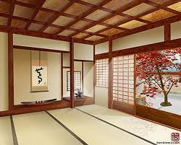
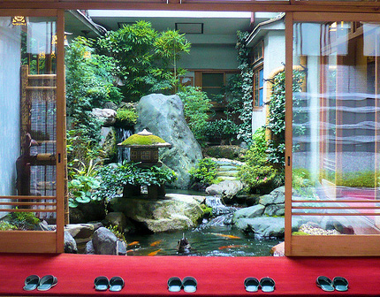
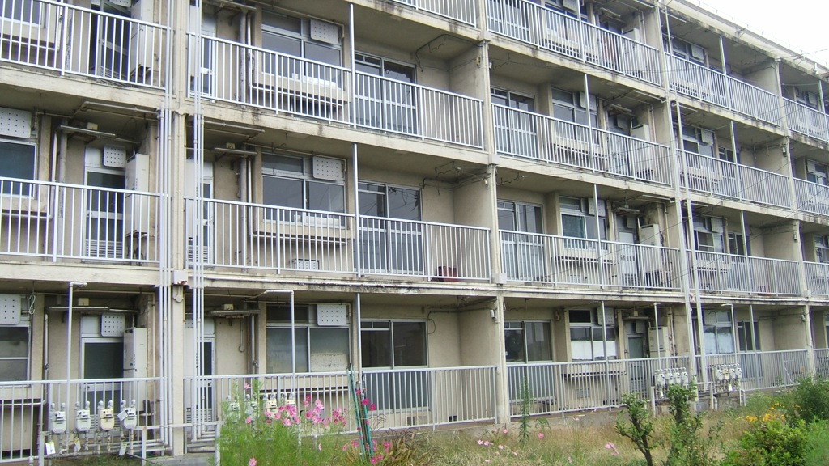
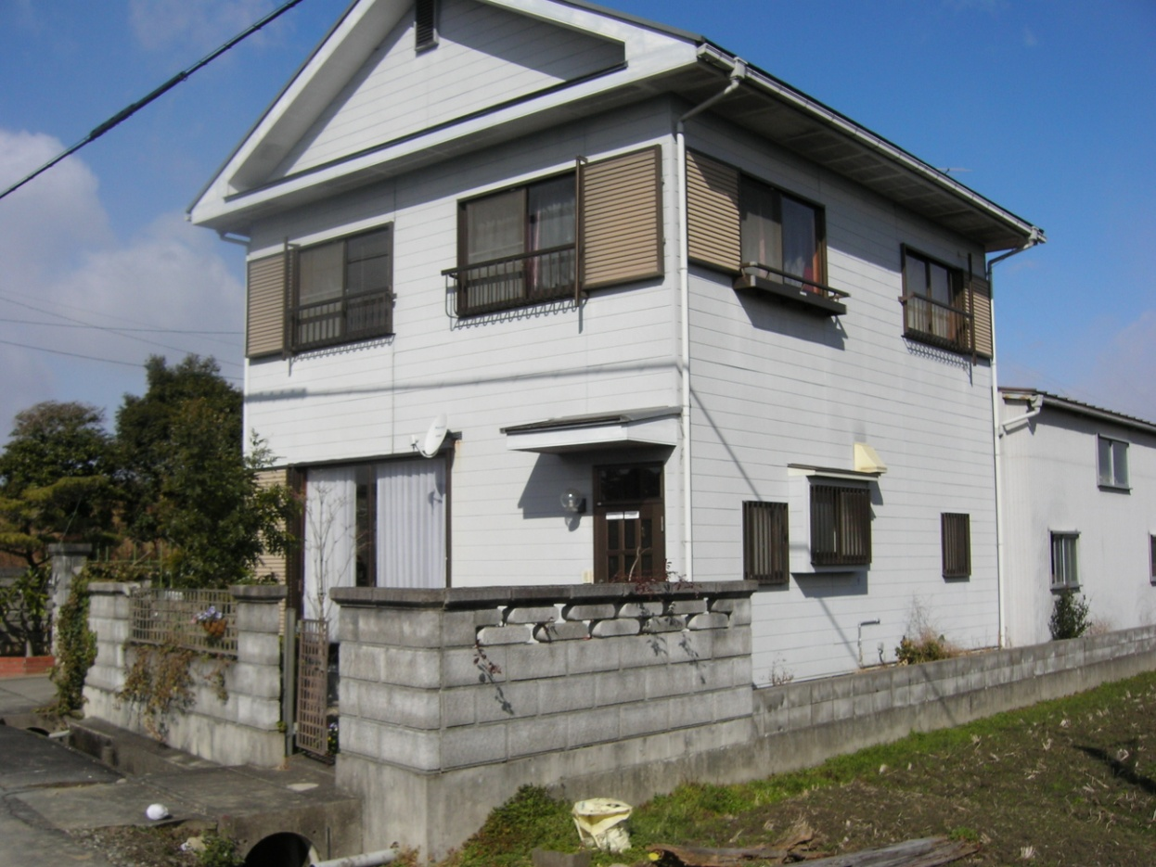
WORD LIST
APAATO BATHROOM BIDET
BUTSUDAN CUPBOARD DAIDOKORO
DAININGU DININGROOM ENTRANCE
GENKAN GETABAKO KICHIN
KITCHEN LIVINGROOM MANSION
MONOIRE RIBINGU ROBE
RYOKAN SENMENSHITSU SHATAKU
SHOEBOX SLIPPER SUIHANKI
TATAMI TOILET TOIRE
TOKONOMA WASHITSU WASHROOM
WESTERNSTYLE YOKUSHITSU YOOSHITSU

