クライブ
ジャッキ
エイブ
モナ

ハーブ
セルマ
パッティ
ホマー
マージュ
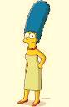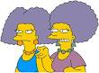

バート
マッギ
リサ

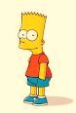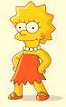

- Label each character with their family position in Japanese, from the perspective of an outsider i.e Maggie is the baby, Lisa is a younger sister
- Answer the following questions about the Simpson family.

- かぞく は なん 人 です か。(immediate family)

- かぞく は なん 人 です か。(the whole family)

- Write the names, in katakana, of each family member in the space provided.

おかあさん あかちゃん おばあさん

おとうさん おにいさん いもうと

Write the hiragana or kanji for these words:

Mother older sister grandfather

Father older brother grandmother

