Family – Sentence Practice
Imagine you are the person circled in each picture. Describe your family including how many people, who they are, pet(s) and their ages. If you know the description words (adjectives), such as ‘tall’ and ‘kind’, please mention them too.
Here is the example: The Simpsons
Kazoku wa gonin desu. Chichi to haha to ani to imouto desu. Petto wa inu to neko desu. Chichi wa sanjuu hassai desu. Haha wa sanjuu roku sai desu. Ani wa jussai desu. Imouto wa ni sai desu. Watashi wa hassai desu. Chichi wa omoshiroi desu. Haha wa yasashii desu.

The Flintstones
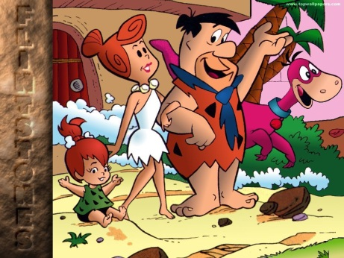
The Incredibles
Family Guy

