なまえ：_______________
かぞく
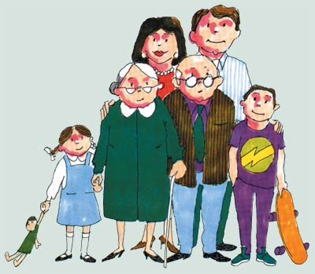
QUESTION 1: Label the photos below with the family members (mother, father, grandad etc) in Japanese. Start by labelling yourself with ぼく(me).

ぼく

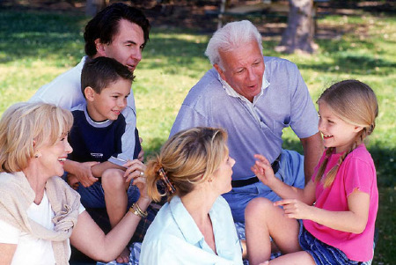

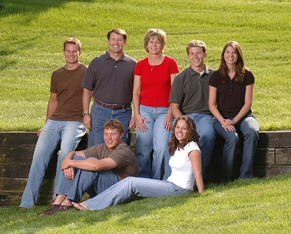

QUESTION 2: Complete the hiragana words below by filling in the missing characters on the blank lines. The first one has been done as an example.
EG.おとうとさん Little brother
＿ か ＿ ＿ ん Mother
お ＿ い さ ＿ Grandad
＿ ＿ あ さ ん Grandma
お ね ＿ ＿ ＿ Big _________
い ＿ う＿ さ ん _______ sister
お ＿ う ＿ ＿ Father
＿ に ＿ さ ん Big ＿＿＿＿

QUESTION 3: Unscramble the following words and work out what family member they are supposed to be. The first one is done as an example.
EG.
SCRAMBLED | UNSCRAMBLED | ENGLISH
じおさんい | おじいさん | Grandad
んにさいお
あかんさお
おさんあば
とんとおさう
えおんさね
んさうとお
いとんうもさ

