Place **15 bombs** in the squares below. When your sentence gets called you can cross that square because it has blown up!

**Do you like~ ?**

MC900280685[1]

**Conversation**

＿＿＿＿＿　が　すき　です　か。

Do you like　　＿＿＿＿＿？

はい、＿＿＿＿＿＿が　　だいすき・すき　です。

Yes, I 　love/like　＿＿＿＿＿.

**OR**

いええ、＿＿＿＿＿＿が　　まあまあすき・あまりすきじゃない・すきじゃない　です。

No it’s OK, like it a little, dislike ______.

|  |  |  |  |  |
| --- | --- | --- | --- | --- |
|  |  |  |  |  |
|  |  |  |  |  |
|  |  |  |  |  |
|  |  |  |  |  |
|  |  |  |  |  |
|  |  |  |  |  |
|  |  |  |  |  |
|  |  |  |  |  |
|  |  |  |  |  |

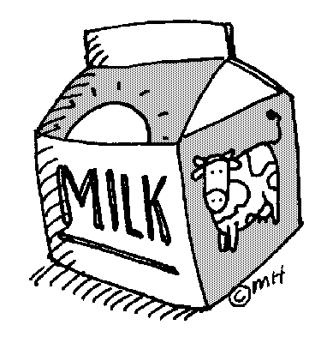

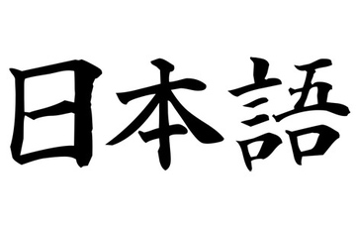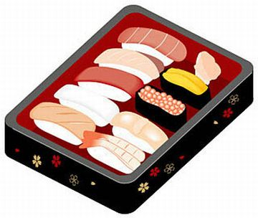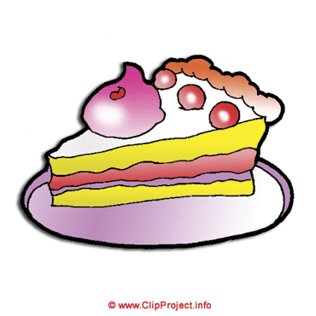

すきじゃない

あまりすきじやないあやない

まあまあすき

すき

だいすき