これはゆぎです
This is Yugi
Follow the instructions to give Yugi some colour.

- Colour his hair オレンジ  - Colour his Jacket あお  - Colour his cards あか  - Colour his gloves むらさき | - Colour his face きいろ  - Colour his buttons くろ  - Colour his eyes みどり  - Colour his shirt ピンク
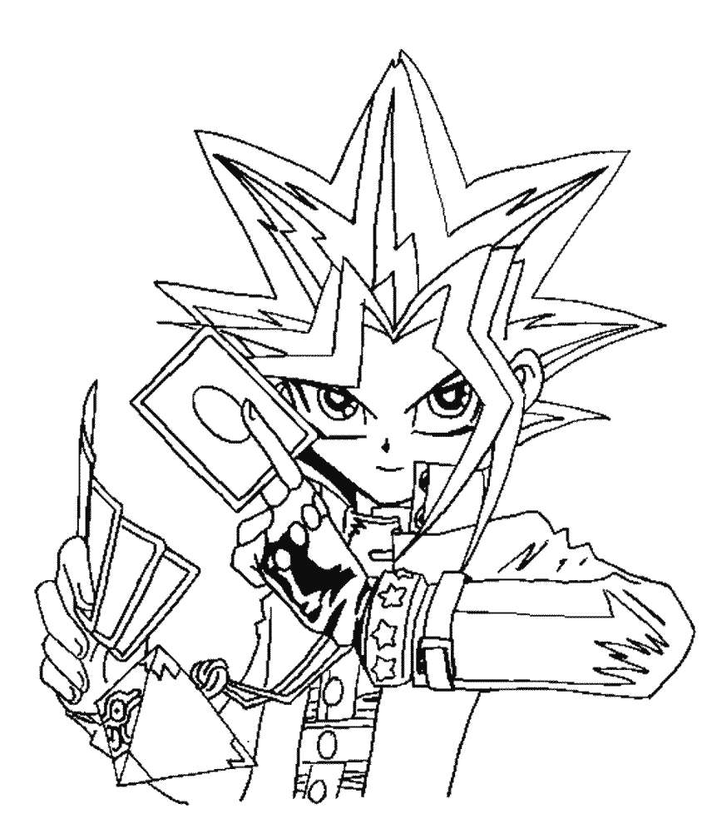
みんなさん、こんにちは！

