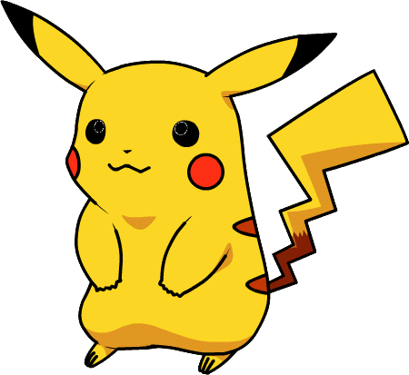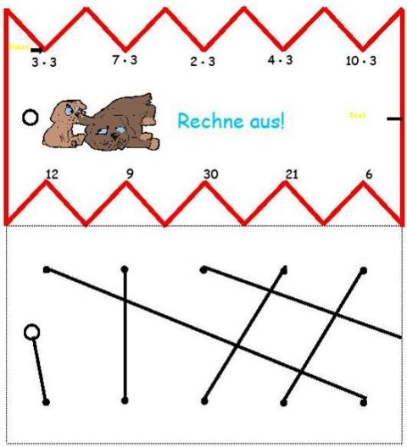 

**え**

**がんばって！**

Try your best!

**がんばって！**

Try your best!

O

**お**



E

**う**

U

**い**

I

**あ**

A

**く**

**き**

**こ**

**か**

**け**

KO

KE

KU

KI

KA

 

**せ**

**がんばって！**

Try your best!

**がんばって！**

Try your best!

TO

TE

TSU

CHI

TA

SO

**そ**

せ

SE

**す**

SU

**し**

SHI

**さ**

SA

**つ**

**ち**

**と**

**た**

**て**

Have a go !

Have a go !

 

**ね**

**がんばって！**

Try your best!

**がんばって！**

Try your best!

HE

HO

FU

HI

HA

NE

NU

NI

NA

NO

**の**

**ぬ**

**に**

**な**

**ふ**

**ひ**

**ほ**

**は**

**へ**

Have a go !

Have a go !



RI

RA

RE

RU

RO

**れ**

**ら**

**ろ**

**り**

**る**

**め**

**ま**

**も**

**み**

**む**

ME

MU

MO

MI

MA

**がんばって！**

Try your best!

**がんばって！**

Try your best!



YU

YO

WA

YA

**を**

**や**

**よ**

**わ**

**ゆ**

WO

RU

RO

RI

RA

**れ**

**ら**

**ろ**

**り**

**る**

RE

**がんばって！**

Try your best!

**がんばって！**

Try your best!