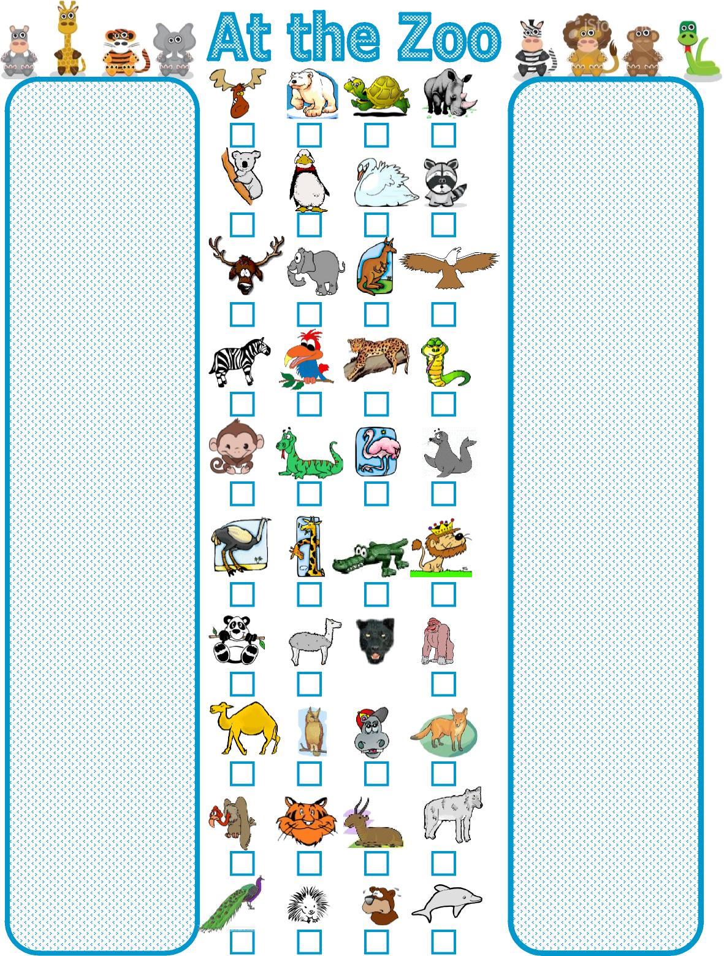
1 ぞう
2 ペンギン
3 ライオン 4さる
5 とら
6 さい
7 はくちょう
8 あざらし
9 ゴリア
10 くま
11 かめ
12 わし
13だちょう
14 おおかみ
15 ほっきょくぐま 16わに
17 へび
18 しか
19 きつね
20 らくだ
21 かば
22 とかげ
23 きりん
24 しまうま
25 コアラ
26 ラマ
27 アンテロープ
28 いるか
29 カンガルー
30 パンダ 31ひょう
32 はげわし
33 あらいぐま 34おうむ
35 へらじか
36 やまあらし
37 くじゃく 38ふくろう
39 フラミンゴ
40 くろひょう

Answer Key:

35
25
18
24
4
13
30
20
32
37
15
2
1
34
22
23
26
38
5
36
11
7
29
31
39
16
40
21
27
10
6
33
12
17
8
3
9
19
14
28

