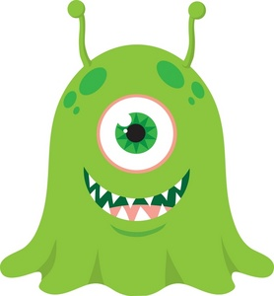
Konnichi wa!
Watashi wa Midori desu.
Juuni sai desu.
Tanjoubi wa sangatsu desu.
Nihon to sushi ga suki desu.
Watashi wa Kasei kara kimashita.
こんにちは！
わたし は みどり です。
十二 さい です。
たんじょうび は 三月 です。
にほん と すし が すき です。
わたし は かせい から きました。

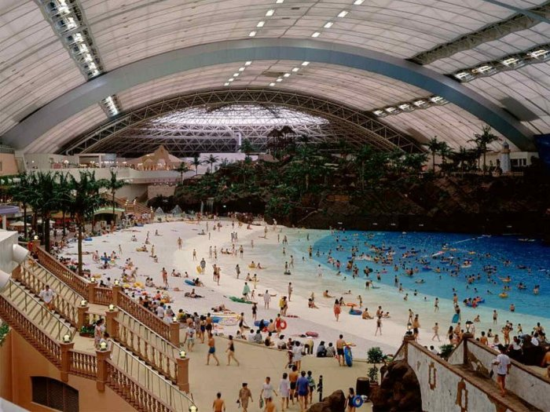
http://www.alltraveltips.com/oceandome.html
７月 に みやさき に いきます。
オーシャンドーム に いきます。
しんかんせん で いきます。
およぎ に いきます。
1600円 です。

Sichi gatsu ni, Miyasaki ni ikimasu.
Ooshandoomu ni ikimasu.
Shinkansen de Ikimasu.
Oyogi ni ikimasu.
1600 en desu.

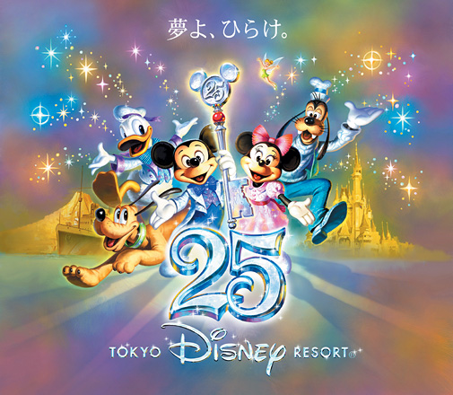
http://www.tokyodisneyresort.co.jp/tdl/index_e.html
とうきょう に いきます。
とうきょうディズニーランド というの
ゆうえんち に いきます。
ひこうき で いきます。
5000円 です。

Tookyooi ni ikimasu.
Toukyou Deizuniirando toiuno
yuuenchi ni ikimasu.
Hikouki de ikimasu.
5000 en desu.
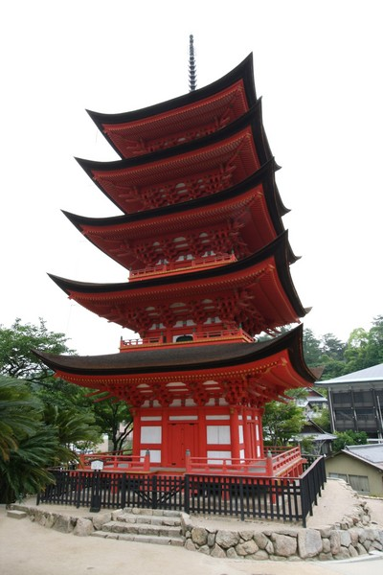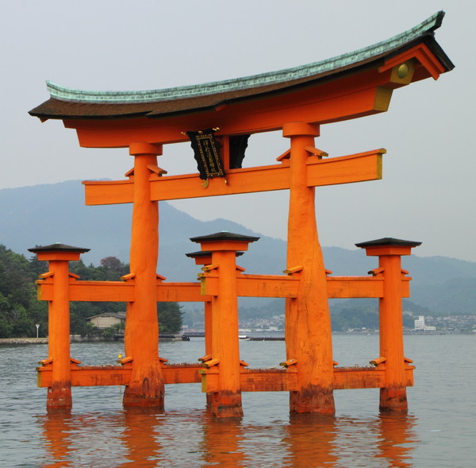
http://www.japaneselifestyle.com.au/travel/miyajima_travel.html
みやじま に いきます。
ふね で いきます。
けんぶつ に いきます。
おてら と じんじゃ を みます。
340円 です。

Miyajima ni ikimasu.
Fune de ikimasu.
Kenbutsu ni ikimasu.
Otera to jinja o mimasu.
340 en desu.
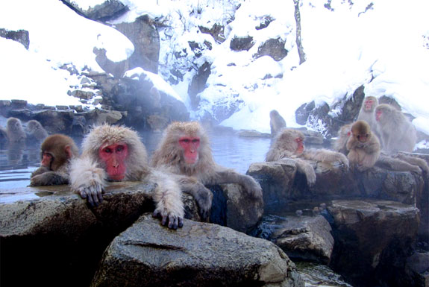
http://travel.spotcoolstuff.com/japan/jigokudani-monkey-hot-springs
でんしゃ で ながの に いきます。
おんせん に いきます。
やまのぼり に いって、さる を みます。
250円 です。

Densha de Nagano ni ikimasu.
Onsen ni ikimasu.
Yamanobori ni itte, saru o mimasu.
250 en desu.
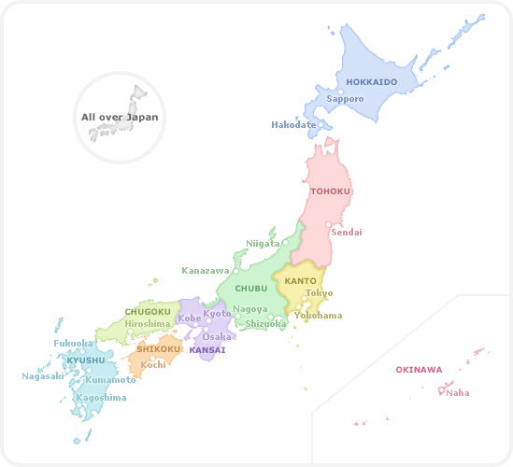http://www.jnto

http://www.jnto.go.jp/eng/indepth/history/traditionalevents/index.htm

