けいようしのれんしゅう

- Write an appropriate adjective for the images below.

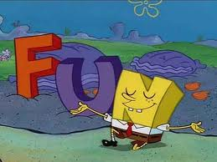
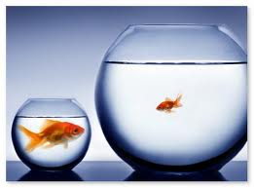
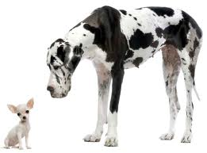

___________________ _________________ _______________
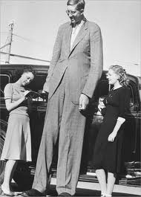

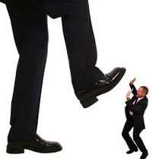
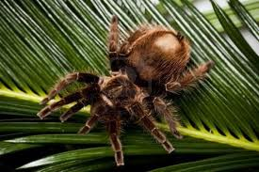

___________________ ___________________ _______________

- Match the following words to the correct meaning

Handsome うるさい
Cute ながい
Pretty/clean ハンサムな
Noisy きれいな
Dirty かわいい
Long みじかい
Short きたない

- Label the body parts on the alien below
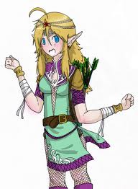

- Translate the following sentences into English.

- かれ は かみのけ が みじかい です。
＿＿＿＿＿＿＿＿＿＿＿＿＿＿＿＿＿＿＿＿＿＿＿＿＿＿
- サムさん は せが たかい です。
_________________________________________________________
- ともだち は 目 が おおきい です。

- Write 3 sentences describing this person’s physical appearance.

- Translate the following sentences. Remember to follow this rule when joining adjectives:
いadjective = drop the い and add くて
な adjective = drop the な and add で

- がっこう は おおきくて、こわい です。
＿＿＿＿＿＿＿＿＿＿＿＿＿＿＿＿＿＿＿＿＿＿＿＿＿＿＿＿
- せんせい は きびしくて、まじめな です。
＿＿＿＿＿＿＿＿＿＿＿＿＿＿＿＿＿＿＿＿＿＿＿＿＿＿＿＿
- うみ は きれいで、ちいさい です。
＿＿＿＿＿＿＿＿＿＿＿＿＿＿＿＿＿＿＿＿＿＿＿＿＿＿＿＿
- My friend is kind and handsome.
________________________________________________________
- The dog is cute and brown.
＿＿＿＿＿＿＿＿＿＿＿＿＿＿＿＿＿＿＿＿＿＿＿＿＿＿＿＿

- Fill in the table below changing each adjective into the negative form. Some have been done for you.

ENGLISH | JAPANESE (+) | JAPANESE (-)
Fun
Delicious
Strict
Small
Big
Boring
Pretty/clean
Kind/nice

