Joining adjectives with くて・で
Translate the following sentences into Japanese:
Example: Volleyball is fun and interesting.
バレーボールはたのしくておもしろいです。

1) Calligraphy is traditional and interesting.
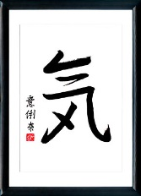
__________________________________________________________________________
2) Baseball is cool and fun.
__________________________________________________________________________
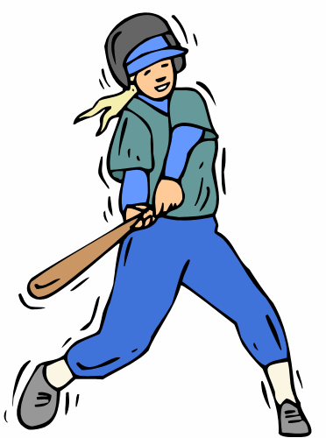
3) Tea ceremony is quiet and easy.
__________________________________________________________________________
4) Basketball is good for your health and cool.
__________________________________________________________________________
5) Soccer is fun and good for your health.
_______________________________________________________________
6) Swimming is easy and fun.
_______________________________________________________________
7) Kendo is interesting and traditional.
_______________________________________________________________
Extra: If you finish early, write your own sentences below:
_________________________________________________________________________________
_________________________________________________________________________________
_________________________________________________________________________________
